Concrete Noun

🔹 What is Concrete Noun
# Source: AI Source: Provided by: [Data Path: Persons Table -> ID Column: 1, Name_En Column: Motasem Essam] -> From: [Chatgpt (GPT-4-turbo)] on [7/26/2025]
A concrete noun is a noun that refers to something you can experience with your five senses:
👀 See – 👂 Hear – 👃 Smell – 👅 Taste – 🤲 Touch

✅ Definition:
# Source: AI Source: Provided by: [Data Path: Persons Table -> ID Column: 1, Name_En Column: Motasem Essam] -> From: [Chatgpt (GPT-4-turbo)] on [7/26/2025]
A concrete noun names something that has physical existence — something you can touch, see, hear, smell, or taste.

🧱 Examples of Concrete Nouns:
# Source: AI Source: Provided by: [Data Path: Persons Table -> ID Column: 1, Name_En Column: Motasem Essam] -> From: [Chatgpt (GPT-4-turbo)] on [7/26/2025]
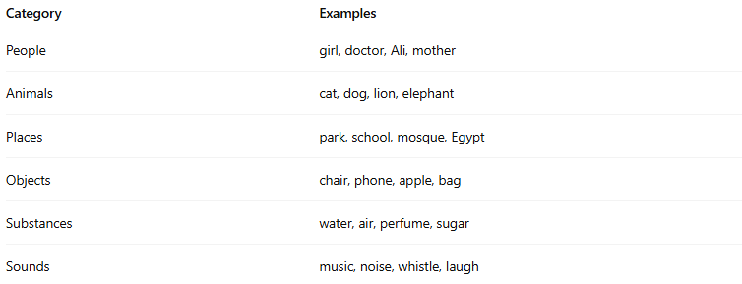
Category | Examples
People | girl, doctor, Ali, mother
Animals | cat, dog, lion, elephant
Places | park, school, mosque, Egypt
Objects | chair, phone, apple, bag
Substances | water, air, perfume, sugar
Sounds | music, noise, whistle, laugh

📝 Example Sentences:
# Source: AI Source: Provided by: [Data Path: Persons Table -> ID Column: 1, Name_En Column: Motasem Essam] -> From: [Chatgpt (GPT-4-turbo)] on [7/26/2025]
- I hear music from the other room. 🎵
- She held a red apple in her hand. 🍎
- We visited the park yesterday. 🌳
- The cat is sleeping on the sofa. 🐱🛋️

🔄 Opposite: Abstract Noun
# Source: AI Source: Provided by: [Data Path: Persons Table -> ID Column: 1, Name_En Column: Motasem Essam] -> From: [Chatgpt (GPT-4-turbo)] on [7/26/2025]
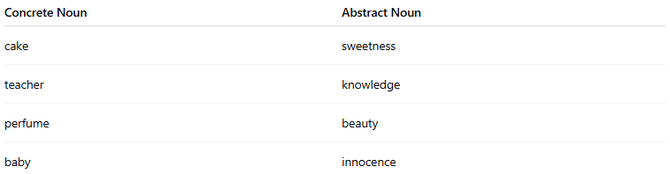
Concrete Noun | Abstract Noun
cake | sweetness
teacher | knowledge
perfume | beauty
baby | innocence

✅ Summary:
# Source: AI Source: Provided by: [Data Path: Persons Table -> ID Column: 1, Name_En Column: Motasem Essam] -> From: [Chatgpt (GPT-4-turbo)] on [7/26/2025]
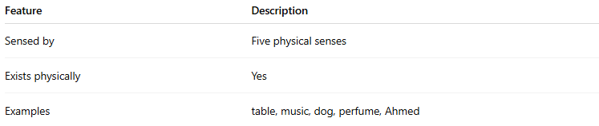
Feature | Description
Sensed by | Five physical senses
Exists physically | Yes
Examples | table, music, dog, perfume, Ahmed

